## Developing for Microsoft Teams

**Lab Time**: 60 minutes

**Lab Folder**: C:\Student\Modules\10_MicrosoftTeams\Lab

**Lab Overview**: In this module, you will work through lab exercises created by the Microsoft Teams product team.

### Exercise 1: Create and test a basic Microsoft Teams app using Yeoman

This is a lab authored by the Microsoft product team.

1. Following this URL for the lab instructions
   1. ssss

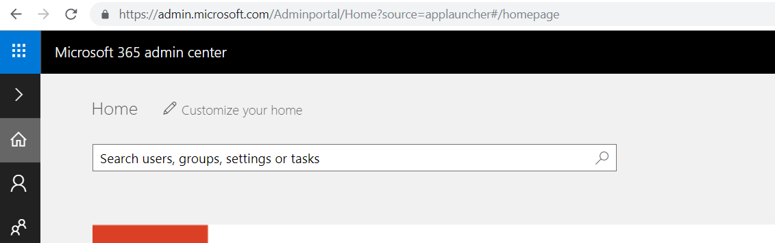

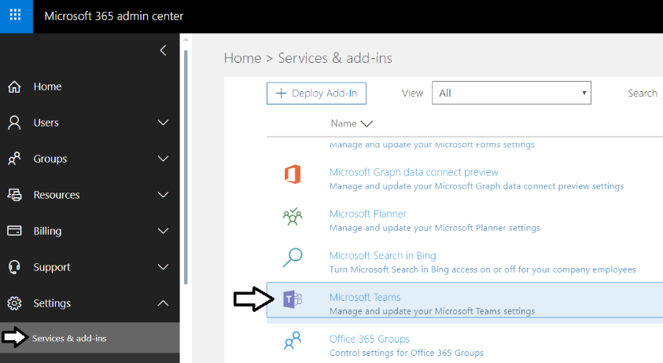

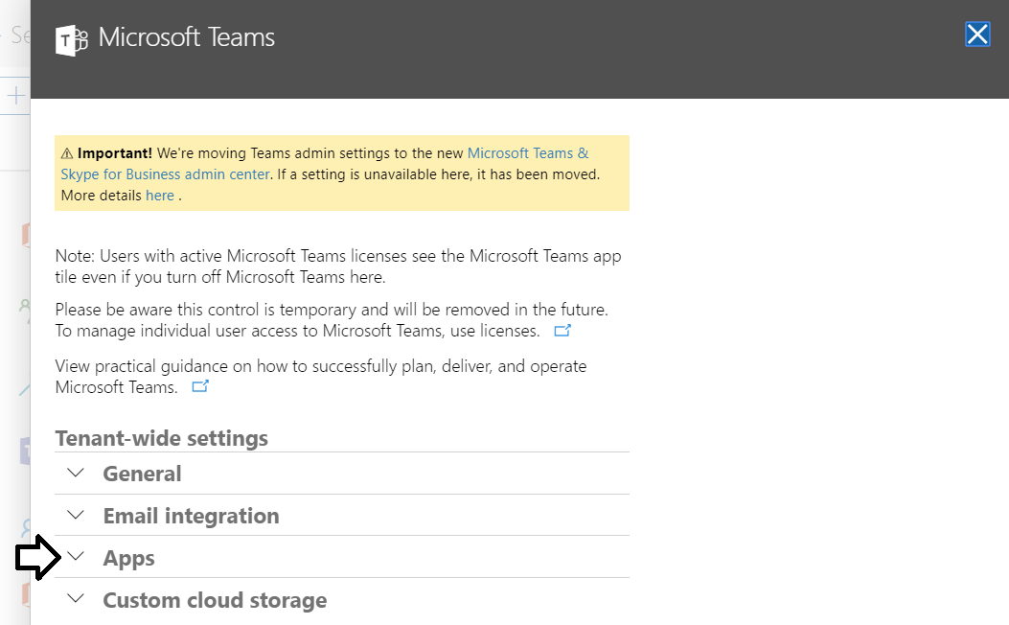

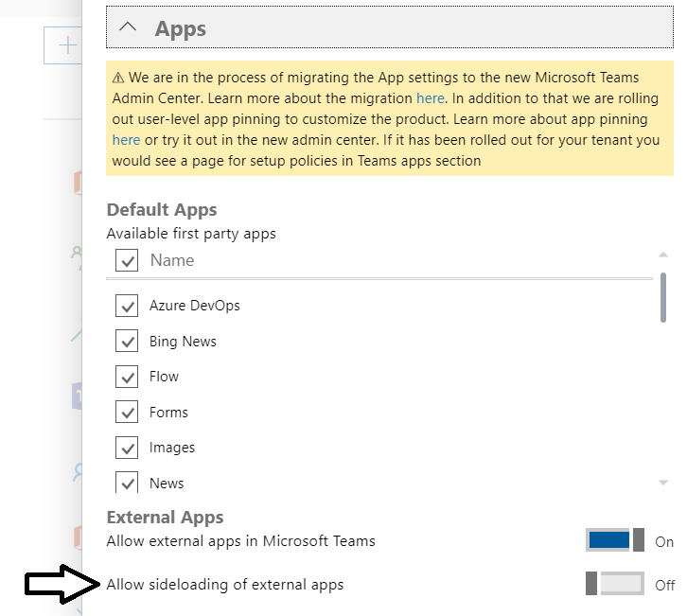

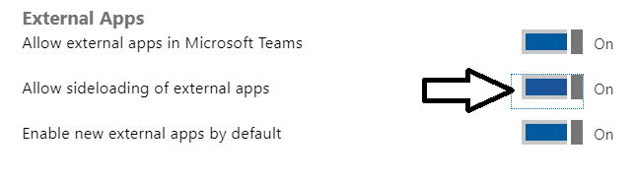



yo @microsoft/sharepoint --plusbeta